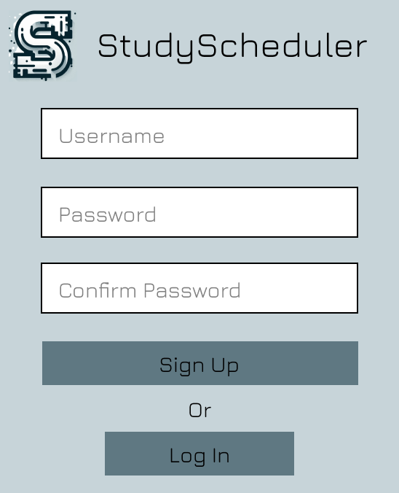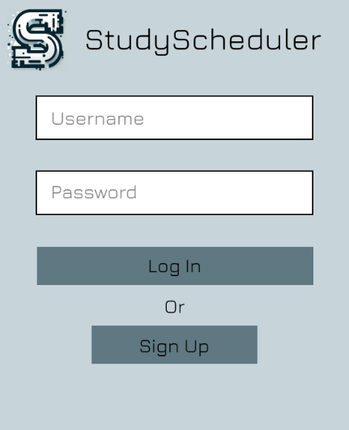User Interface Designs:

Medium Fidelity Sign Up Page

Medium Fidelity Log In Page

Medium Fidelity Main Design

Adding a Reminder

Study Timer Medium Fidelity Prototype

StudyScheduler daily tasks

StudyScheduler Reminders Page

Chosen Calendar Application for Implementation (CalendarFX):

CAB302 Release Plan

Sprint 3 (1/05/24):

* Users will be able to create an account and authenticate themselves into the application.
* Further implementation of UI pages, user will be able to view the following pages:
  + Settings
  + Statistics
  + Calendar
  + All other pages provided in the Medium Fidelity Prototype
* Users will be able to schedule items in the calendar -> implementation of CalendarFX Application.

Sprint 4 (15/05/24):

* Users should be able to access all pages related to the user of the application.
* All main pages as outlined previously have been implemented and are usable by the user.
* In essence, the user should be able to sign into the application, schedule items in a calendar, study for allotted periods of time, and view statistics related to their calendar-items and completion.

Final Release (29/05/24):

* Implementation of select ‘should-have’ user stories.
* Application should be fully functional for the purposes of its use by the end-user.

Project Management Trello Images:

Trello Main Page 1

User Story & Acceptance Criteria Image 2

User Story & Acceptance Criteria Image 3

User Story & Acceptance Criteria Image 5

User Story & Acceptance Criteria Image 4

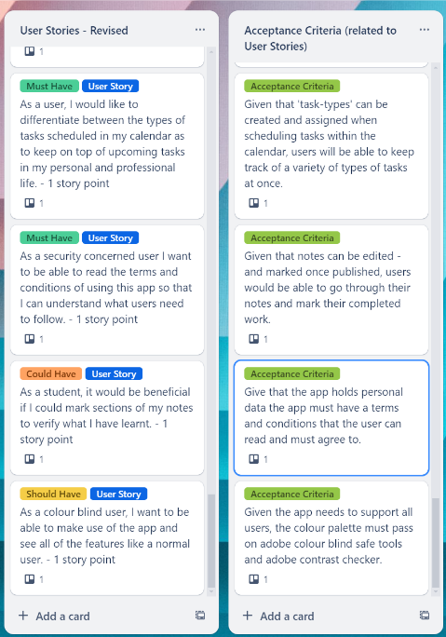

User Story & Acceptance Criteria Image 6

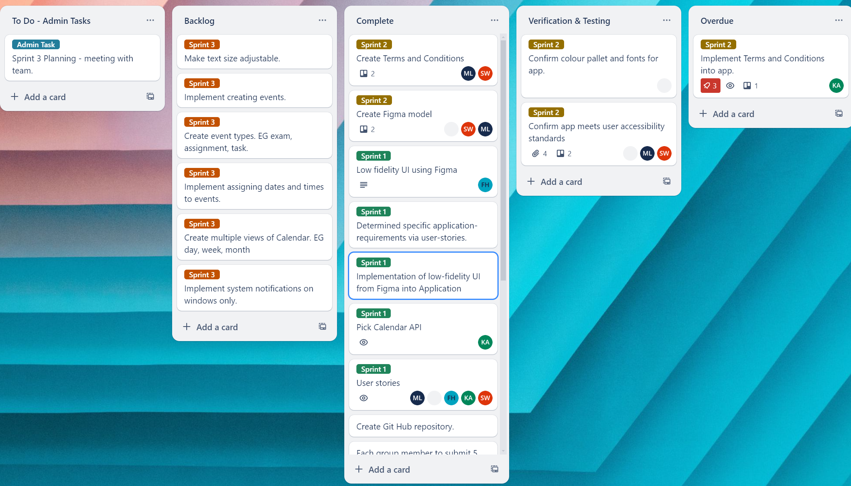

Remainder of the Trello Board

**Application Implementation**

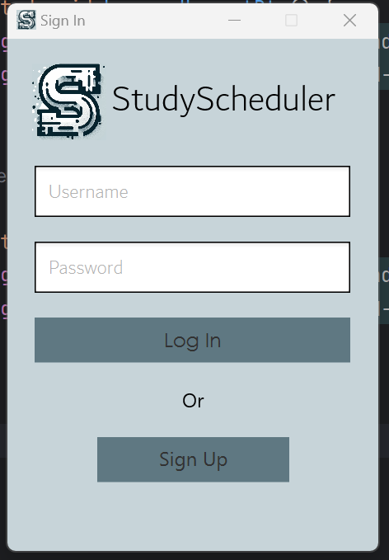

Sign Up Page in Application

Sign in Page in Application

Main Page of Application